# **Global Superstore Dashboards**

## **Shipments Delivery Analysis**

### **a. Key Visualizations**

1. **KPI Tiles (Top Row):** Highlight key performance indicators and summary statistics.
2. **Line Chart - Delayed Orders Ratio Over Time:** Illustrates the monthly trend of delayed delivery ratios, with annotations marking the highest and lowest points.
3. **Map - Delivery Status by Country:** Depicts global delivery performance, using color coding to differentiate between on-time and delayed shipments.
4. **Bar Chart - Average Delivery Time by Region and Status:** Shows a regional comparison of average delivery days, distinguishing on-time deliveries (green) from delayed ones (red).
5. Filters, Parameters and Conditional highlighting, Navigation features enable dashboards interactive.

### **b. Interpretation**

1. **From KPI:** 82% of shipments are on time, which is good, but nearly 1 in 5 are delayed, which is an area for improvement. The 4-day average delivery time is reasonable but could be shortened to boost competitiveness.
2. **From Line Chart:** Delivery performance fluctuates, with delay spikes likely due to seasonal or operational factors. The highest delay (24%) was in Mar-13, and the lowest (~12%) in Nov-13 and Mar-11.
3. **From Map:** Delivery performance varies by region, with China facing significant delays, possibly due to logistics or supplier issues.
4. **From Bar Graph:** Central and South regions face longer delays, while EMEA and North America show more consistent, efficient delivery performance.

### **c. Strategic Recommendations**

1. **Optimize High-Delay Regions:** China and Central region should be prioritized for operational review. Investigate supplier performance, last-mile logistics, customs/border delays and check for alternative vendors.
2. **Predict and Prevent Delays:** Analyze historical spikes (e.g., March & July) for root causes and adjust inventory and logistics capacity with forecasted demand and utilize predictive analytics to flag high-risk shipments.
3. **Improve Delivery Standards:** Reduce the average delivery time from 4.0 to under 3.5 days to enhance customer satisfaction.
4. **Customer Communication:** Proactively notify customers in high-delay zones of potential shipment issues. Offer incentives for flexible delivery timelines in delay-prone regions.

## **Shipments Performance Analysis**

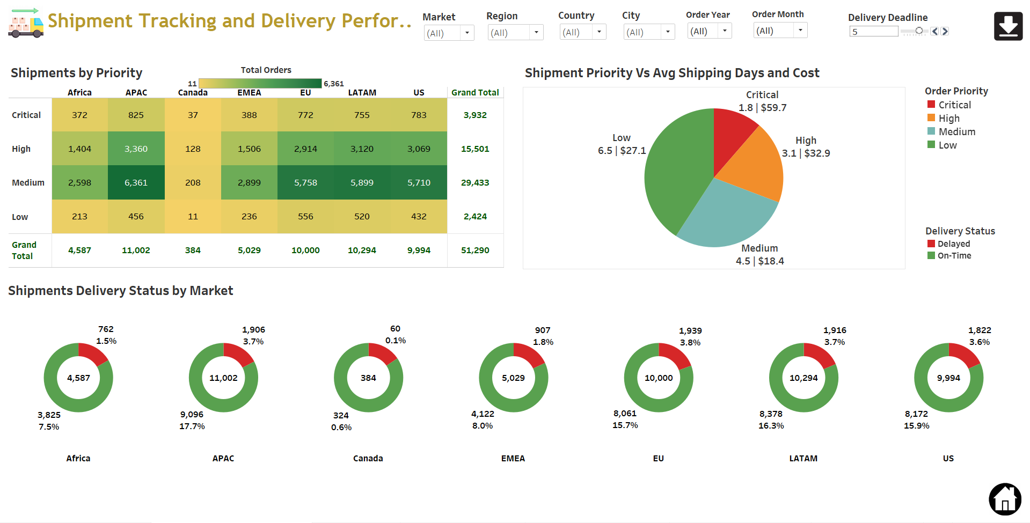

### **a. Key Visualizations**

**1. Shipments by Priority (Heatmap Table):** Provides orders counts from different markets against different shipment priorities.

**2. Shipment Priority vs Avg Shipping Days and Cost (Pie Chart):** Provides average delivery days against each shipment priority and associated average shipping cost.

**3. Shipments Delivery Status by Market (Donut Charts):** Provides Shipment performance in different Markets.

### **b. Interpretation**

1. **For Heat Map:** Most shipments are Medium priority (57%), with few Critical orders (6.6%), likely reserved for urgent needs. APAC handles the highest volume across all priority levels.
2. **From Pie-Chart:** Critical shipments are fastest (1.8 days) but costliest. Low priority is slowest (6.5 days) and oddly costlier than Medium, which is the most cost-efficient.
3. **From Donut Chart:** Canada leads in on-time delivery (65%) but has low volume. LATAM and EU have the highest delays (~41%). No region exceeds 66% on-time-a key concern.

### **c. Strategic Recommendations**

**1. Focus on Improving On-Time Deliveries:** With on-time rates below 65%, improvement is needed, especially in LATAM and EU (delays >40%). Focus on predictive ETAs, stronger vendor SLAs, carrier accountability, and root cause analysis of warehouse or customs delays.

**2. Rethink Low Priority Logistics:** Low-priority shipments take 6.5 days and cost more than medium, indicating inefficiencies. Audit partners, check for costly delays or re-routing, and consolidate loads to optimize.

**3. Balance Cost and Speed for High-Critical Orders:** Critical orders are costly but fast, suitable for urgent needs. High-priority makes up 30%, so avoid overuse by adding justification controls for high-cost shipments.

**4. Regional Strategy Tailoring:** APAC handles the highest volume and needs sustainable scaling with more warehouse automation and supplier collaboration. Canada, with the best delivery rates, should be a benchmark for other regions.